LCD Icon Introduction

1.1 LCD Icons of the Wired Controller

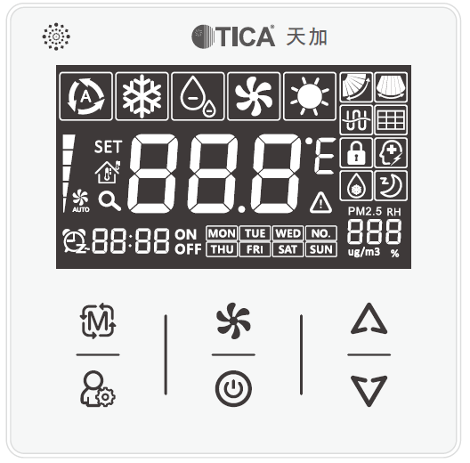

Figure 1.1 Appearance

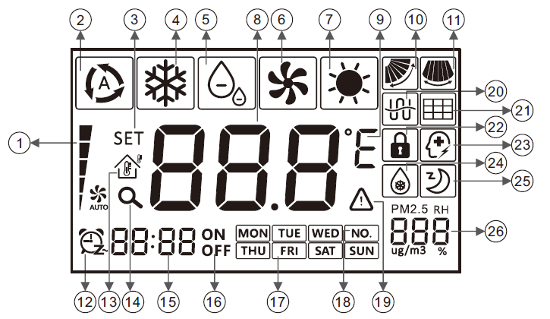

Figure 1.2 LCD icons

V1.0

LCD Icon Introduction

1.2 Icon Description

Table 1.1 Icon description

|  |  |  |
| --- | --- | --- |
| **No.** | **Name** | **Description** |
| 1 | Fan speed | Current fan speed (including four options: auto, low, medium, and high) |
| 2 | Auto | AUTO MODE (In auto mode, the indoor unit changes its running mode based on the indoor temperature.) |
| 3 | Settings | Display the "SET" icon in the unit parameter setting interface. |
| 4 | Cool | Fan coil cooling mode |
| 5 | Dry | Dehumidification mode |
| 6 | Fan | Air supply mode |
| 7 | Heat | Heating mode |
| 8 | Temperature area | 1. Display the preset temperature or return air*/*wire controlled temperature.  2. Display the error code when an error occurs.  3. Display Hon/HOF of Auxiliary heater. |
| 9 | Temperature unit | Display the icon of Celsius or Fahrenheit during unit setting. |
| 10 | Vertical swing | Display the vertical swing. |
| 11 | Horizontal swing | Display the horizontal swing. |
| 12 | Clock | 1. Displayed during system time setting  2. Displayed when the timing function is enabled |
| 13 | Return air or wire controlled temperature | Display the return air or wire controlled temperature. |
| 14 | Query | Display the query icon in the unit parameter setting interface. |
| 15 | Clock digital display | Display the system clock (or display the scheduled time during timing setting). |
| 16 | Power-on/off | Display the ON/OFF icon after timing setting. |
| 17 | Days of the week | Display days of the week. |
| 18 | Address No. | Display the address number. |
| 19 | Error | Display the error status. |
| 20 | Energy saving | Display the energy saving status. |
| 21 | Filter | Display the filter status. |
| 22 | Child lock | Display the child lock status. |
| 23 | Power failure memory | Display the status of power failure memory. |
| 24 | Defrosting | Defrosting status |
| 25 | Sleep | Display the sleep status. |
| 26 | PM2.5, humidity, IDU address | Display the PM2.5, humidity, and current IDU address. |

Remark: When the wired controller works with different indoor units, the functions may vary with the unit.

Button Introduction

2.1 Buttons

# 

2.2 Button Description

Table 2.1 Button description

|  |  |  |
| --- | --- | --- |
| **Icon** | **Name** | **Function** |
|  | Mode | (1) Switch among modes of auto, cool, dry, fan, and heat of the indoor unit.  (2) Function as the OK button during parameter query as well as swing, timing, and system time setting. |
|  | Fan speed | (1) Switch fan speed among modes of low, medium, high, and auto.  (2) Function as the Cancel button during parameter query as well as swing, timing, and system time setting. |
|  | Increase | (1) Timing setting  (2) Parameter query  (3) System time setting  (4) Temperature setting |
|  | Decrease |
|  | Function | (1) Parameter setting or query  (2) Function as the OK button during day selection of week timing ON/OFF. |
|  | On/Off | (1) Power on or off the indoor unit.  (2) Function as the Cancel button during day selection of week timing ON/OFF. |
| Combination:  and | Sleep | Hold  and  simultaneously to start or cancel the sleep mode. |
| Combination:  and | Switchover between Fahrenheit and Celsius temperature. | Hold  and  simultaneously for 3s to switch between Fahrenheit and Celsius. |
| Combination:  and | Switchover between the preset temperature and room temperature. | Hold  and  simultaneously for 3s to start or cancel temperature switchover. |
| Combination:  and | Child lock | Press and hold  and  simultaneously for 3s to set the child lock status. |
| Hold | Electric auxiliary heater | Hold  for 5s to set the auxiliary heater status. |
| Hold | Swing | Hold  for 5s to set the swing status. |
| Hold | System time | Hold  for 5s to set the system time. |

Operation Instruction

3.1 Power On/Off

Press  to start the air conditioner. Press  again to stop it.

3.2 Mode Setting

Press  to switch among modes in the following sequence:

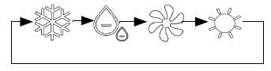

Cool

Dry

Fan

Heat

#### Notes:

1. If the outdoor unit is in Off mode, the indoor unit mode switches in the following sequence:

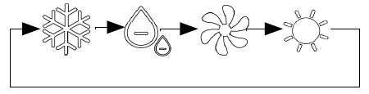

Cool

Dry

Fan

Heat

2. If the outdoor unit is running in Cool mode, the indoor unit mode switches in the following sequence:

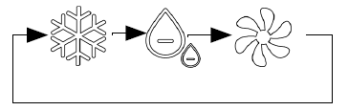

Cool

Dry

Fan

3. If the outdoor unit is running in Heat mode, the indoor unit mode can only be  (Heat).

3.3 Temperature Setting

When the unit is powered on/off, press  or  to increase or decrease the preset temperature by 1°C. If you press and hold the buttons, the temperature increases or decreases by 1°C every 0.4s.

If Celsius temperature is displayed, the settable value ranges from 16°C to 30°C.

If Fahrenheit temperature is displayed, the settable value ranges from 61°F to 86°F.

3.4 Fan Speed Setting

When the unit is powered on, press  to switch among fan speed modes in the following sequence:

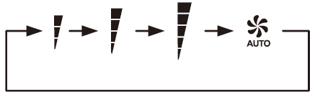

Low

Medium

High

Auto speed

#### Notes:

When the fan speed of the indoor unit is set to auto, the indoor unit automatically changes the fan speed based on the indoor ambient temperature to make the indoor ambient temperature stable and comfortable.

Operation Instruction

### 3.5 Function Setting and Query

When the unit is powered on/off, press  to select function settings or query unit parameters.

### 3.5.1 Function Setting

Settable functions of the wired controller include timing (001), week timing ON (002), week timing OFF (003), IDU operation temperature selection (004).

#### 3.5.1.1 Timing

When the unit is powered on, you can set the shutdown countdown time. When the unit is powered off, you can set the startup countdown time.

(1) timing setting:

Set the timing in the following sequence:



Press once

Press

or

Press

or

➀ Press  once to display the "SET" icon. Press  or  to display the  icon. When the humidity digital display shows , press .

➁ When digital display of the hour and minute  flashes, press  or  to set the time. Then, press  to confirm the change.

➂ A: When the device is on, **OFF** flashes. Press  to complete settings and exit.

B: When the device is off, **ON** flashes. Press  to complete settings and exit.

➃ After steps ①, ② and ③ are performed,  flashes, and **OFF** or **ON** is displayed.

(2) Canceling timing:

When the timing function is on, press . After the "SET" icon is displayed, press  or . After the  icon is displayed, press . The digital display of the hour and minute flashes. Press  to cancel the set timing.

(3) Automatically exiting timing setting:

If no operation is performed within 10s after in the timing setting interface, the wired controller automatically exits timing setting.

Notes:

1. Maximum value of the timing: 24 hours When  or  is pressed once, the timing value increases or decreases by 0.5 hours. When the buttons are pressed and held, the value increases or decreases by 0.5 hours every 0.4s accordingly.

2. The timing ON and timing OFF functions cannot be enabled simultaneously. You can use the week timing function to make the timing take effect in a certain period.

3. The week timing and timing cannot be set simultaneously.

Operation Instruction

### 3.5.1.2 Week Timing ON

Before setting the week timing ON/OFF function, calibrate the clock.

#### (1) Setting week timing:



or

Week

Hour

Minute

➀ Press  once to display the "SET" icon. Press  or  to display the  day icon. When the humidity digital display shows , press .

➁ Take an example that the  icon flashes. Press  or  to select the required days (for example, Monday, Wednesday, and Friday). When  flashes, press .  is solid on; press  or  to change to .  flashes. Press .  is solid on; press  or  to change to .  flashes. Press .  is solid on. When  are on and no icons of other days flash, press  to confirm day settings and switch to time setting.

➂ When the hour icon 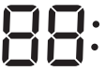 flashes, press  or  to select the required hour, and then press  to confirm the hour setting.

➃ When the minute icon 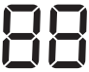 flashes, press  or  to select the required minute, and then press  to confirm minute settings.

➄ When the **ON** icon flashes, press  to confirm timing ON/OFF settings.

➅ After the preceding steps are finished,  is solid on, and the **ON** icon is displayed.

#### (2) Canceling timing:

When the timing function is on, press . After the "SET" icon is displayed, press  or . The +day icon is displayed. When the humidity digital display shows , press . The digital display of the hour and minute is steady on, and the icon of days flashes. Press  to cancel the week timing ON. The  and **ON** icons are off accordingly.

#### (3) Automatically exiting timing setting:

If no operation is performed within 10s in the timing setting interface, the wired controller automatically exits timing setting and retains the current week timing ON/OFF status.

### 3.5.1.3 Week Timing OFF

The settings of week timing OFF is similar to that of week timing ON. For details, refer to the operations of week timing OFF.

Operation Instruction

#### 3.5.1.4 IDU Operation Temperature Selection

**(1) How to set**

Press ****. After the "SET"icon is displayed, press  or . When the humidity Digital display shows, press .

When the temperature digital display shows  (IDU temperature) or  (wire controlled temperature), press  or  to select the required parameter. Press  to confirm parameter settings and exit.

**(2) How to cancel**

During parameter setting, press  to cancel settings and retain the current operation parameters.

**(3) Automatic exit**

If no operation is performed within 10s in the IDU operation temperature setting interface, the wired controller automatically exits and retains the current operation parameters.

**Notes:**

1. During parameter setting, other functions cannot be set and the remote control signal is invalid.

2. During timing setting, the minute value can only be 0 or 30.

3. During week timing setting, after pressing  or  in step ②, you must press  or , and then press . The order cannot be reversed; otherwise, the week timing setting will fail.

4. When you enter the week timing ON/OFF setting interface again after setting timing, the days previously set are normally displayed in step ②, and no icons of other days flash. If you do not need to modify the days, press , and then press  to switch to time setting. If you need to modify the days, press  or  to select days. Press  to retain a day and press  to cancel a day. Then press  to switch to time setting.

5. If no operation is performed within 10s in the above status, the wired controller exits week timing setting. When you enter the week timing setting interface again, if no icons of days flash, follow the above instructions in point 4. If any icon flashes, follow step ②.

6. When the timing or week timing is on, and you modify the timing again, the wired controller automatically exits if any operation is not finished within 10s, and the modified timing will be adopted.

7. During week timing setting, the times of pressing  is limited. If the settings fail, press  to cancel week timing setting, and then perform operations according to related instructions.

8. The default IDU operation temperature parameter is 00 (IDU return air temperature).

9. The "IDU temperature selection function" of TMDN-AG and TMCF-AG models is set by using the wired controller instead of running the related command.

10. When the wired controller is powered on, the backlight is on for 60s by default. The backlight will be off 20s after the button operation is completed.

11. When a fault occurs, the wired controller flashes with the backlight solid on. After the fault is rectified, the default backlight status is restored.

Operation Instruction

**3.5.2 Parameter Query**

Press  twice to display the  icon. Press  or  to view the corresponding parameter.

|  |  |  |
| --- | --- | --- |
| Code | Parameter | Remarks |
| 01 | Temperature | The  icon is displayed. Press . Press  or  to select (return air temperature) or (wire controlled temperature).  1. Press  to confirm the temperature to be queried and exit.  2. Press  to exit the parameter query function. |
| 02 | PM2.5 | The currently set temperature is displayed in the temperature digital display area, and the current PM2.5 value is displayed in the PM2.5 digital display area. (To enable this function, you need to install an air quality detector.)  1. Press  to display the PM2.5 value.  2. Press  to cancel the display of the PM2.5 value. |
| 03 | Humidity | The currently set temperature is displayed in the temperature digital display area,  The humidity digital display shows the current humidity. (To enable this function, you need to install an air quality detector.)  1. Press  to display the humidity value.  2. Press  to cancel the display of the humidity value. |
| 04 | IDU Address | The temperature digital display shows the currently set temperature, and the address digital display shows the current IDU address. The values are displayed for 4s only. |
| 05 | Program Version | The temperature digital display shows the current wired controller program version for 4s each time only. |

Operation Instruction

#### Notes:

1. The wired controller exits the parameter query interface if no operation is performed within 10s.

2. In parameter query 1, press  to confirm the parameter be queried and exit. To display the return air temperature or wire controlled temperature, press  and .

3. During parameter query, other functions cannot be set and the remote control signal is invalid.

#### 3.6 Swing Setting

The swing function is used to balance the indoor temperature.

#### (1) Enabling the swing function

When the unit is powered on, hold  for 5s, and the  icon flashes. Press  to enable the swing function and exit. The swing icon is solid on.

#### (2) Disabling the swing function

1. When the unit is powered on with the swing function enabled, hold  for 5s, and the  icon flashes. Press  to disable the swing function and exit. The swing icon is off.

2. During the swing setting, you can press  to exit.

#### (3) Automatic exit

If no operation is performed within 10s in the swing setting interface, the wired controller automatically exits the swing setting.

Note: During swing setting, other functions cannot be set and the remote control signal is unavailable.

#### 3.7 Switch between Fahrenheit and Celsius Displaying Fahrenheit temperature

When the Celsius temperature is displayed, hold  and  simultaneously for 3s to switch to Fahrenheit temperature.

#### Displaying Celsius temperature

When the Fahrenheit temperature is displayed, hold  and  simultaneously for 3s to switch to Celsius temperature.

Note: By default, the Celsius temperature is displayed.

Operation Instruction

#### 3.8 Sleep Function Setting

Sleep Function: When the IDU enters the sleep mode, it runs according to the sleep temperature curve to create a comfortable environment and improve your sleep quality.

#### How to set:

When the unit is powered on, hold  and  simultaneously for 3s. When the  icon is on, the sleep function is started.

#### How to cancel:

1. When the unit is powered on, hold  and  simultaneously for 3s. When the  icon is off, the sleep function is canceled.

2. When you change the mode or power off the unit, the  icon is off, indicating that the sleep function is canceled.

3. When you enable the energy saving function, the  icon is off, indicating that the sleep function is canceled.

**Note:** The sleep function is unavailable in fan mode.

#### 3.9 Switch Between Preset Temperature and Room Temperature

Displaying the room temperature:

When the preset temperature is displayed, you can press and hold  and  simultaneously for 3s to display the room temperature.

Displaying the preset temperature:

When the room temperature is displayed, hold  and  simultaneously for 3s to display the preset temperature.

#### Notes:

1. By default, the preset temperature is displayed.

2. When the room temperature is displayed, if you press the wire controller button to set parameters, the currently set temperature is displayed. The room temperature will be displayed in 5s after the operation is finished.

3, If the wire controlled temperature sensor is faulty, the controller automatically switches to the PCB air return temperature.

#### 3.10 Auxiliary Heater Setting

Controlling the auxiliary heater: In heating mode, you can enable the auxiliary heater to increase the air discharge temperature and make the environment more comfortable. The auxiliary heater is available only in heating mode.

#### Enabling the auxiliary heater:

When the auxiliary heater function is disabled, hold  for 5s to enable the auxiliary heater. The Hon icon will be displayed in the temperature digital display area, and the temperature value will be displayed 2s later.

Operation Instruction

**Disabling the auxiliary heater:**

When the auxiliary heater function is enabled, hold  for 5s to disable the auxiliary heater. The HOF icon will be displayed in the temperature digital display area, and the temperature value will be displayed 2s later.

#### Notes:

1. When you change the mode using a wired or remote controller, the auxiliary heater is disabled by default.

2. The "auxiliary heater disabling function" of TMDN-AG and TMCF-AG models is set by using the wired controller instead of running the related command.

#### 3.11 Child Lock

Child lock: After setting parameters on the wired controller, you can set the child lock to prevent misoperation by children or other people. When the child lock is on, no operation can be performed.

How to set:

Press  and  simultaneously for 3s to start the child lock function. If the icon is solid on, the wired controller is locked.

How to cancel:

Press  and  simultaneously for 3s again. If the icon is off, the child lock is canceled.

#### 3.12 System Time Setting

Set the clock if the time displayed is different from the correct time.

**How to set:**

When the unit is powered off, hold  for 5S to enter the system time setting interface. When the +day icon is displayed, press  and adjust the time in the following sequence:

Week

Hour

Minute



Operation Instruction

➀ When the  icon flashes, press  or  to select the required day (for example, ). Then press  to confirm the day setting.

➁ When the hour icon  flashes, press  or  to select the required hour, and then press  to confirm the hour setting.

➂ When the minute icon  flashes, press  or  to select the required time, and then press  to confirm minute settings and exit. The currently set system clock will be displayed in 7s.

#### How to cancel:

When the unit is powered off, press and hold  for 5s to enter the system time setting interface. When the +day icon is displayed, press  to cancel system time setting. The shutdown interface will be displayed.

#### Automatic exit:

During system time setting, if no operation is performed within 10s, the controller exits system time setting and the regular shutdown interface will be displayed.

#### Notes:

1. During system clock setting, the system will not respond to remote control signal and other function setting.

2. When you press and hold  or , the time increases or decreases rapidly.

Operation Instruction

#### 4. Engineering Debugging Function

When the unit is powered off, press  and  simultaneously for 3s. After the  icon is displayed, you will enter the engineering debugging mode. Press  or  to set the corresponding parameters.

|  |  |  |
| --- | --- | --- |
| Parameter Type | Parameter | Remarks |
| 01 | IDU address setting | Maximum address 64 |

4.1 IDU Address Setting

**(1) How to set**

① When the unit is powered off, press  and  simultaneously for 3s. After the  icon is displayed, you will enter the engineering debugging mode. Press  or . When the icon is displayed, press  to enter.

② Press  or  to adjust the tens digit to the required address and press  to confirm. Then press  or  to adjust the units digit to the required address, and press  to confirm and exit.

#### (2) How to cancel

When the  icon is displayed, press  to cancel the address setting and exit. The wired controller maintains the current address.

#### (3) Automatic exit

In the process of setting the address, if you do not operate the button for 10 seconds, you will automatically exit the address setting mode. The wired controller maintains the current address.

#### Notes:

1. Address setting range: 0-64

Error Codes

#### Error Codes

|  |  |  |  |  |  |  |
| --- | --- | --- | --- | --- | --- | --- |
| Fault Type | | | Fault Code | Fault Description | | |
| Communication failure of wired controller and IDU | | | 000 | Communication failure of wired controller and IDU | | |
| IDU Fault | | | 800 | Communication failure of IDU and ODU | | |
| 801 | Inlet coil temperature failure | | |
| 802 | Middle coil temperature failure | | |
| 803 | Outlet coil temperature failure | | |
| 804 | Return air temperature failure | | |
| 805 | Reserved | | |
| 806 | Mode conflict | | |
| 807 | Water level fault | | |
| ODU fault  (VRF unit)  Taking the master unit as an example | 100 | INV1 high pressure switch | | | 115 | TH8 temperature fault |
| 101 | FAN1 drive fault | | | 116 | FC1 |
| 102 | INV_COMP1 overload | | | 117 | FC2 |
| 103 | INV1 discharge temperature too high | | | 118 | Master/slave unit 1 communication fault |
| 104 | INV1 drive communication fault | | | 119 | Master/slave unit 2 communication fault |
| 105 | FAN1 drive communication fault | | | 120 | IDU and ODU not matched |
| 106 | INV1 drive overheat fault | | | 121 | LS |
| 107 | INV1 drive fault | | | 122 | HS |
| 108 | TH1 temperature fault | | | 123 | Phase sequence fault |
| 109 | TH2 temperature fault | | | 124 | INV2 high pressure switch fault |
| 110 | TH3 temperature fault | | | 125 | FAN2 drive fault |
| 111 | TH4 temperature fault | | | 126 | INV_COMP2 overload |
| 112 | TH5 temperature fault | | | 127 | INV2 discharge temperature too high |
| 113 | TH6 temperature fault | | | 128 | INV2 drive communication fault |
| 114 | TH7 temperature fault | | | 129 | FAN2 drive communication fault |

Error Codes

|  |  |  |  |  |
| --- | --- | --- | --- | --- |
| ODU fault  (VRF unit)  Taking the master unit as an example | 130 | INV2 drive overheat fault | 135 | Low pressure too low/high |
| 131 | INV2 drive fault | 136 | INV2 discharge superheat degree too high or too low |
| 132 | Insufficient pressure difference/4WV fault | 137 | Ambient temperature too high/low (operation forbidden) |
| 133 | INV1 discharge superheat degree too high or too low | 138 | No communication |
| 134 | High pressure too low (lack of refrigerant) | 139 | System failure |
| ODU fault  (Mini VRF unit) Taking the master unit as an example | 100 | Inverter high pressure switch | 115 | Reserved |
| 101 | Fan drive fault | 116 | Reserved |
| 102 | Reserved | 117 | Reserved |
| 103 | Reserved | 118 | COMP1 overload |
| 104 | Compressor drive communication fault | 119 | Current of the entire unit |
| 105 | Fan drive communication fault | 120 | IDU and ODU not matched |
| 106 | Compressor drive overheat fault | 121 | Low pressure switch |
| 107 | Compressor drive fault | 122 | Reserved |
| 108 | TH1 temperature fault | 123 | Reserved |
| 109 | TH2 temperature fault | 124 | Reserved |
| 110 | TH3 temperature fault | 125 | Reserved |
| 111 | TH4 temperature fault | 126 | Reserved |
| 112 | TH5 temperature fault | 127 | Reserved |
| 113 | TH6 temperature fault | 128 | Reserved |
| 114 | TH7 temperature fault | 129 | Reserved |

Error Codes

|  |  |  |  |  |
| --- | --- | --- | --- | --- |
| ODU fault  (Mini VRF unit)  Taking the master unit as an example | 130 | Reserved | 135 | Reserved |
| 131 | Reserved | 136 | High discharge temperature |
| 132 | Insufficient pressure difference | 137 | Ambient temperature too high/low (operation forbidden) |
| 133 | Insufficient refrigerant | 138 | No communication |
| 134 | Low pressure too high | 139 | System failure |
| Spot check | Flashes | Spot check fault |  |  |

Error code "1+fault No." is shown on the wired controller when a fault occurs to slave unit #1 of the modular unit. Error code "2+fault No." is shown on the wired controller when a fault occurs to slave unit #2 of the modular unit. For example: 103 indicates high INV1 discharge temperature of unit #1. 208 indicates TH1 temperature fault of unit #2.

#### Maintenance:

1. Use a dry and soft cloth to remove the dirt on the LCD screen or the body of the wired controller.

2. If the dirt cannot be removed, use water to dilute neutral detergent, dip the cloth in the diluted detergent, and then wring it out. Use the cloth to remove the dirt. After the dirt is removed, use a dry cloth to wipe the LCD screen or controller.

3. Do not use liquid such as diluent, organic solvent and strong acid.

#### Troubleshooting and after-sales service

When the air conditioner works abnormally, the LCD screen of the wired controller will display the  icon flashing and a fault code to indicate that a fault occurs.

In this case, write down the fault code and contact the after-sales service.

#### For the after-sales service, contact your sales service provider.