

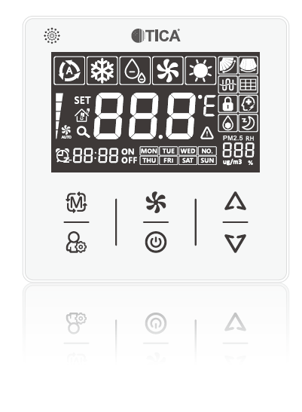

|  |
| --- |
| **Installation Instructions of TICA Wired Controller** |

|  |
| --- |
| **Safety Precautions** |

Before installation, read the precautions on the User Manual of the wired controller to make sure the installation is properly performed.

**Notes:**

1. Before installation, be sure to read the instructions and follow this document during installation.

2. Give the instructions to the user when installation is completed.

3. For use of wired controller, read the User Manual.

4. Please keep the instructions properly for further reference.

|  |
| --- |
| **Checking Accessories** |

In addition to the wired controller, the packing box should also contain:

|  |  |
| --- | --- |
| Installation Instruction × 1 | User Manual × 1 |
| Self-tapping screw × 2 | Connecting wire × 1 |

|  |
| --- |
| **Installation Instructions** |

**1. Choose a place to install the wired controller.**

Follow the Precautions on Installation Instructions to choose a right place for installation.

**2. Remove the front lid of it.**

Insert a flat blade screwdriver here and slightly rotate the front lid to remove it

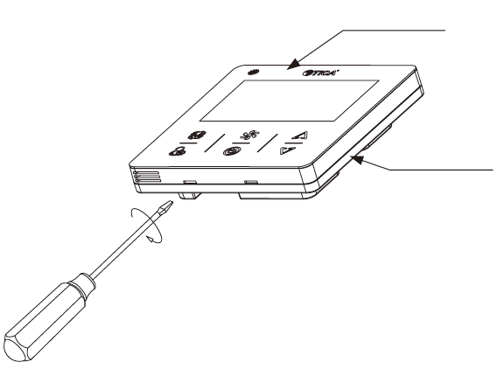

Front lid of wired controller

Bottom lid of wired controller

**Notes:**

Be careful not to scratch the control board of wired controller which is installed at the front lid!

|  |
| --- |
| **Installation Instructions** |

**3. Wired controller wiring.**

(1) Pull out the connecting wire of wired controller.

As shown below, pull out the connecting wire of wired controller from embedded junction box (prepared by user) and through the bottom lid of wired controller to the connecting terminals on the front lid.

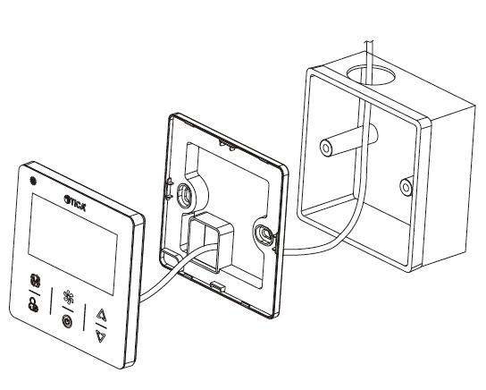

Embedded junction box (prepared by user)

Bottom lid of wired controller

Front lid of wired controller

|  |
| --- |
| **Installation Instructions** |

(2) Wiring.

Make sure the connecting wires are fastened reliably.

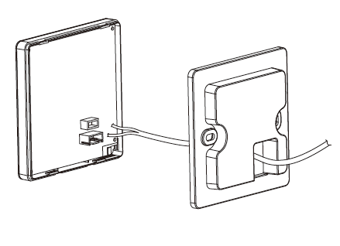

|  |
| --- |
| **Installation Instructions** |

**4. Fix the bottom lid.**

Needs to be installed on the embedded junction box.

Fix it with self-tapping screws attached (2 pcs).

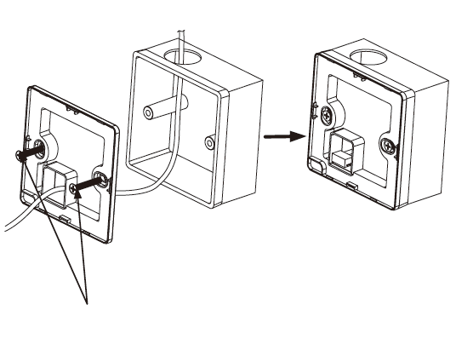

Self-tapping screws

|  |
| --- |
| **Installation Instructions** |

**5. Reattach the front lid.**

Aim the front lid at the corners of wired controller and press it.

Tear off protective film after installation is completed.

